**Lab Process Cloud Service - PCS**

This lab covers the Process Cloud Service.

It is an updated version of a lab from the Oracle Cloud Test Drive series.

# Introduction

In this lab, you will create a business process using PCS. This Order Approvals process will be initiated when a user enters an order. The business logic is as follows:

* Small orders, those < £ 100, will be automatically approved.
* All other orders, let’s call them large, need to be manually approved.
* If an order is rejected, it needs to be sent to Management for a final decision.

There are 3 functional roles within this process –

* OrderEntry
* OrderApproval
* OrderManagement

### Note (for later)

Here is the XSD, defining an Order, you will need to simply copy and paste it later. Skip it for now.

<?xml version="1.0" encoding="windows-1252" ?>

<xsd:schema xmlns:xsd=<http://www.w3.org/2001/XMLSchema>

xmlns="http://www.example.org"

targetNamespace="http://www.example.org"

elementFormDefault="qualified">

<xsd:element name="Order">

<xsd:complexType>

<xsd:sequence>

<xsd:element name="orderNr" type="xsd:string"/>

<xsd:element name="custFirstName" type="xsd:string"/>

<xsd:element name="custLastName" type="xsd:string"/>

<xsd:element name="custEmail" type="xsd:string"/>

<xsd:element name="product" type="xsd:string"/>

<xsd:element name="unitPrice" type="xsd:int"/>

<xsd:element name="quantity" type="xsd:int"/>

</xsd:sequence>

</xsd:complexType>

</xsd:element>

</xsd:schema>

# Logging in to PCS

Log in into cloud:

Use url:

<https://login.us2.oraclecloud.com/oam/server/obrareq.cgi?encquery%3DVq1Z1zbTy65FNmdDtuFlDpMEKZS9oCpUJV3pzbFJHF8VlWI6fvgTJjHF96KbtTh71t3aVsFfRNMVEmpPLRVIXiJTfWc8qzF051NuWg7JC0JCfxbkzJM4f63Hvf7lP0pLjpT44cb8HWa%2FKVmJQ7NcYVLRMNFybW4qBD7moQ5kV96bXTlJuoPqBiubhALbXw4LGTGAKsyxVg%2BxhZye3TiFec5zYEx8ZUvD2%2BO5ZelNx5vXwL%2FQRe0fsdkscvgyz1MrQVYYdyZfZLqSCiJCoYKql356DGTnNA3gzYoChM8OzVr5eXnceq6fssZyr6urbMe%2FOu89FYPQKpPGj%2Fxuh2vFC4UUmmwmTA15Mew4tBsdbF9r%2BNODyoz4sX5b1m%2FwnY6S%2FdhQsGeqqP5FQIqgRyvk64DP5R4bwRlSyekiklAja7sSZOMjiSp4Y2YbyqFhq8wF%20agentid%3DCloudPortalAgent%20ver%3D1%20crmethod%3D2>

* Data Center: us2
* Domain: partnerpaas18
* User: [luc.gorissen@amis.nl](mailto:luc.gorissen@amis.nl)
* Password:

To avoid any possible cache issues:

* In Chrome - Select New Incognito Window
* In Mozilla - Select New private window

Select the Process Cloud Service in the Dashboard:

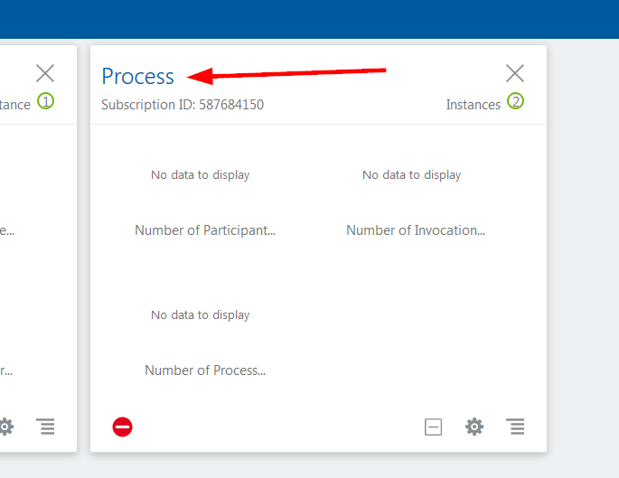

Open the Service Console of the pcs4partners Service Instance:

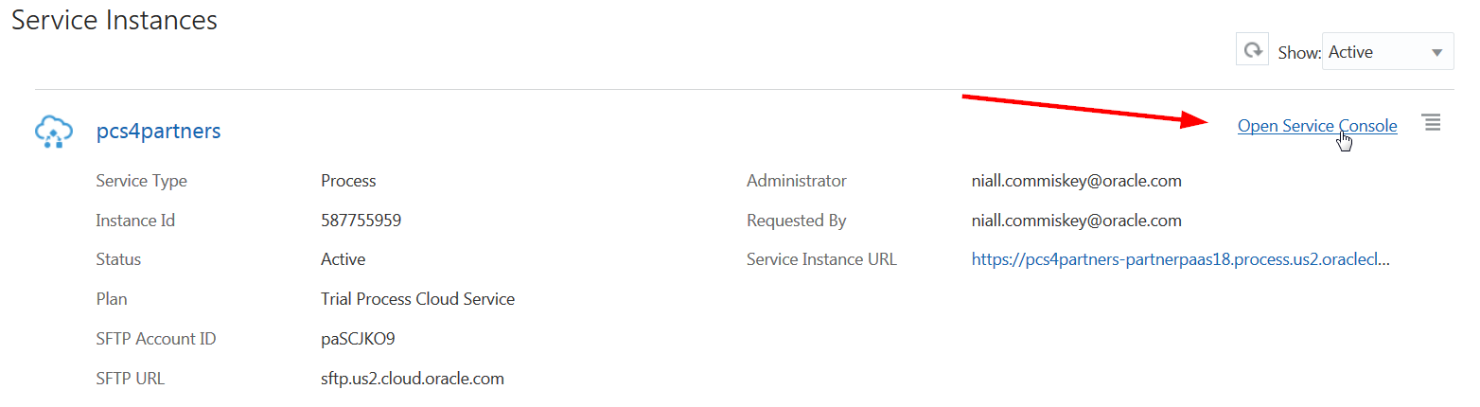

And … you’re logged in:

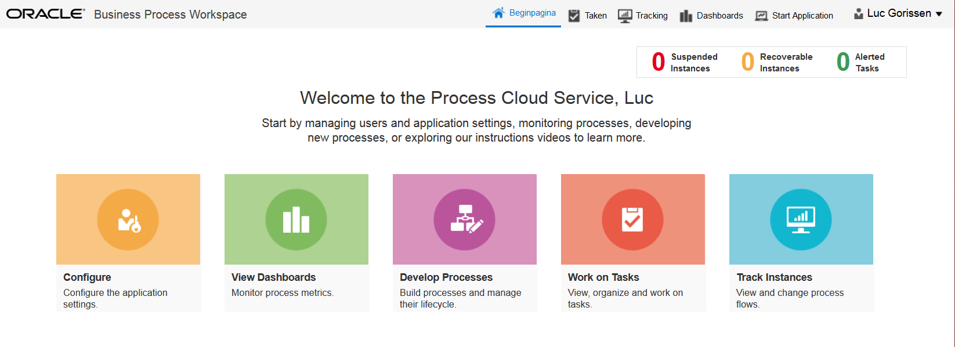

Your instructor will also assign a Prefix – you will not need it for now, only for later

Note: the above screenshot shows the PCS launch page. From here you can do develop processes, work on tasks e.g. approve orders that have been assigned to you. One can also monitor what is going on via tracking.

* Click on Develop Processes
* Click on Composer Home on the top navigation bar

# Create the Process

Click on the “Create” button at the left:

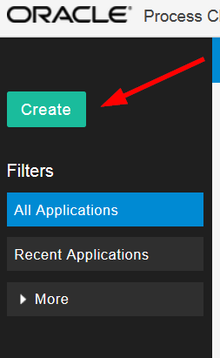

Select to Create a New Space

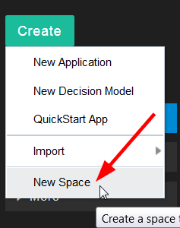

Call the new Space AAXXOrdersSpace, AAXX being the prefix assigned to you by the instructor.

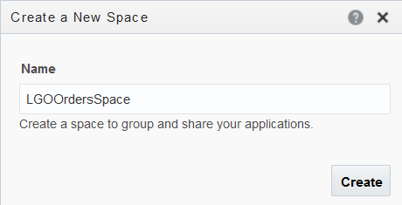

Click on the newly created Space

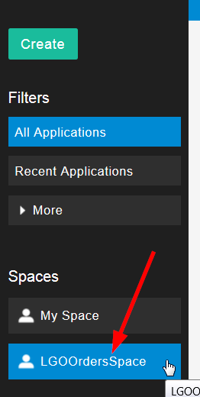

Click on New Application

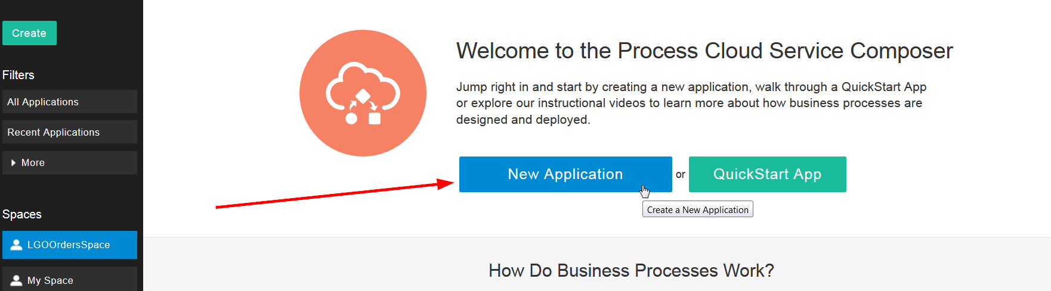

Enter AAXXOrdersApp (where AAXX is the prefix assigned to you)

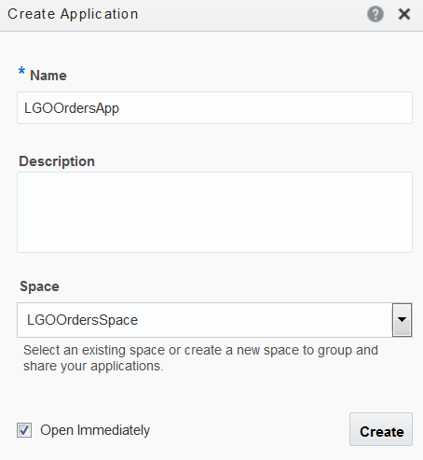

Click Create

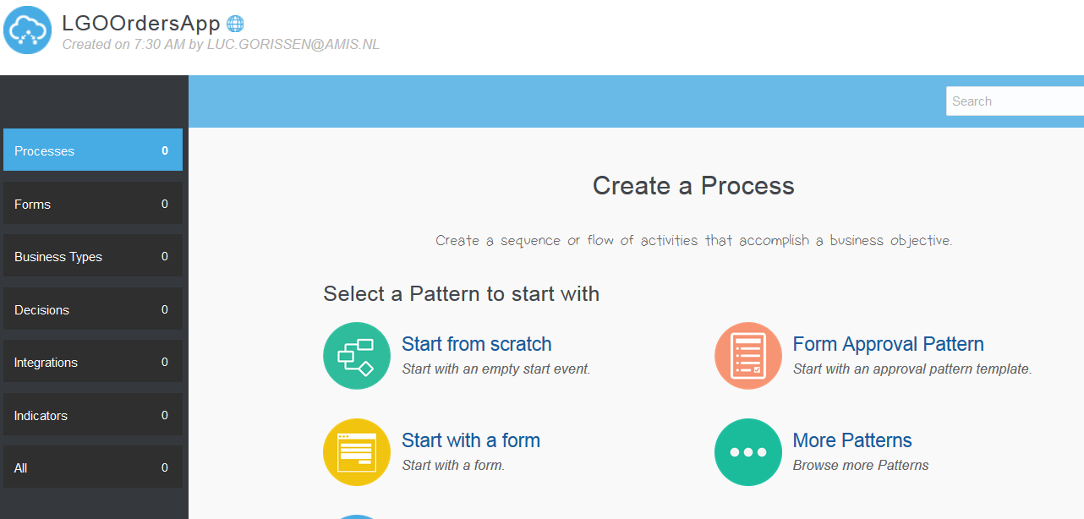

# Create the Order Business Object

Click on Business Types to add the Orders XSD to this application (left hand side of the screen).

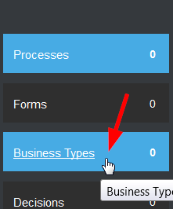

Click on Schema Files

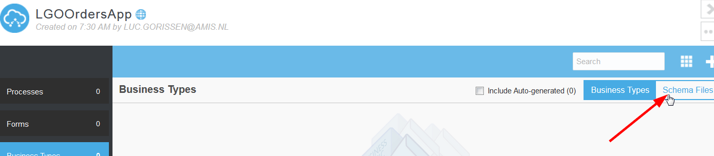

Click on the + to add the XSD

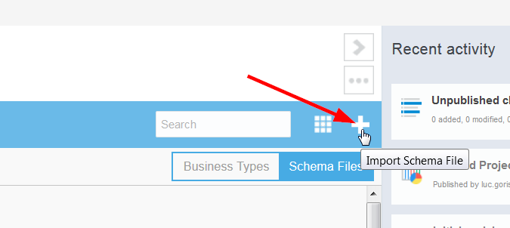

Add the XSD using the definition at the start of this document (create a text file, cut & paste and rename as NCOrder.xsd)

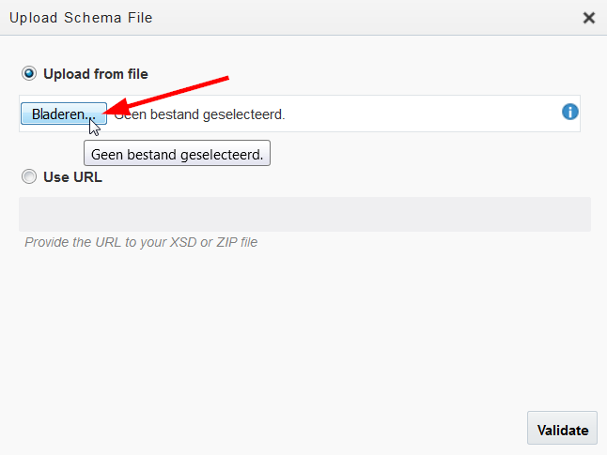

Click Validate

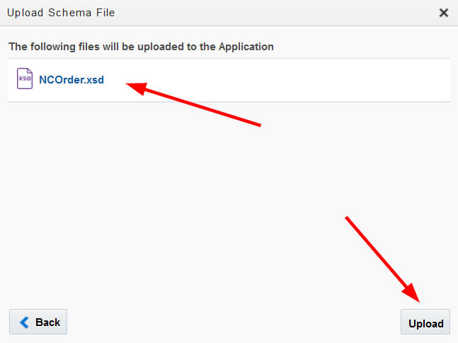

Click Upload

Note: The XSD has been successfully uploaded

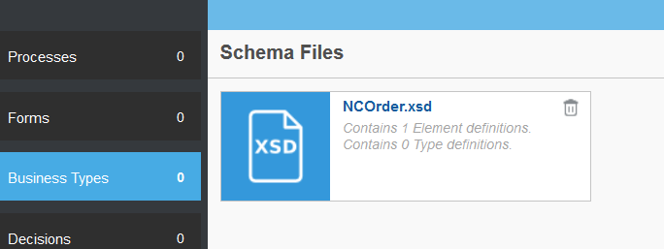

Click on the XSD

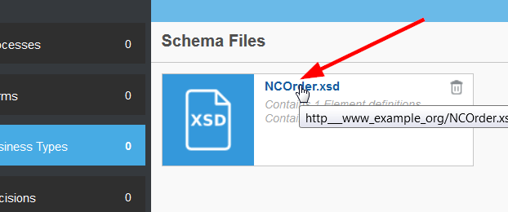

Click on the Promote link

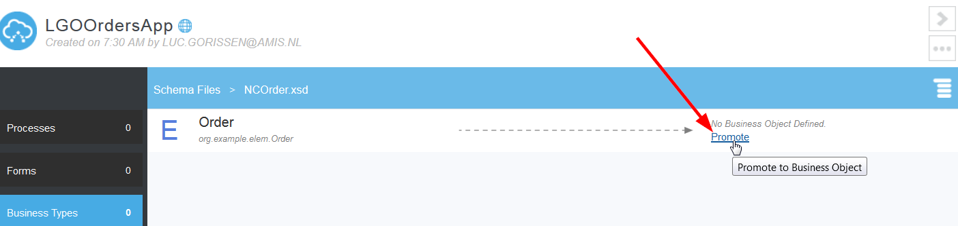

Note: This creates a PCS business object from the Order definition within the XSD.

Name it OrderBO:

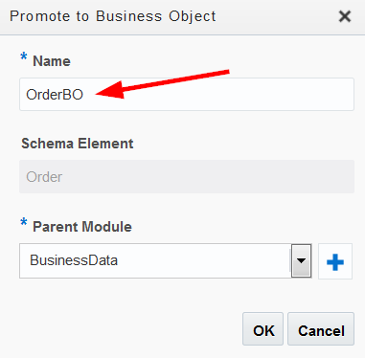

Click Ok

Well done! You have successfully created your first PCS business object. This process could have been done in a graphical way too but we are using the imported file to save some time.

# Create the Order processing form

Click on Forms at the left

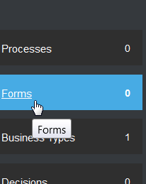

Click on the plus button to create a new form

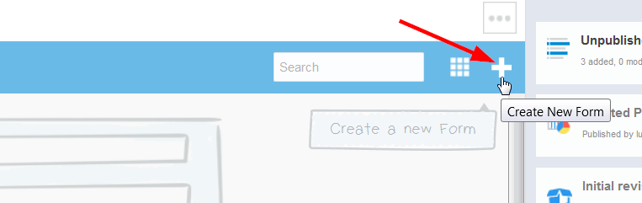

Click on New Web Form

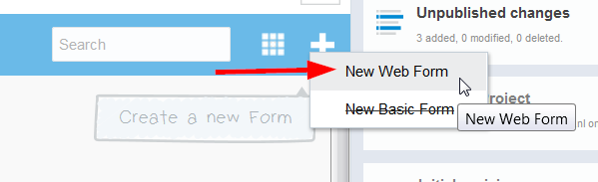

Name the Web Form AAXXOrderWebForm and click ‘Create’

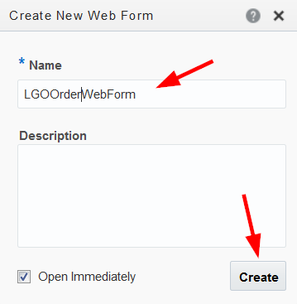

Note: the screenshot shows the forms designer.

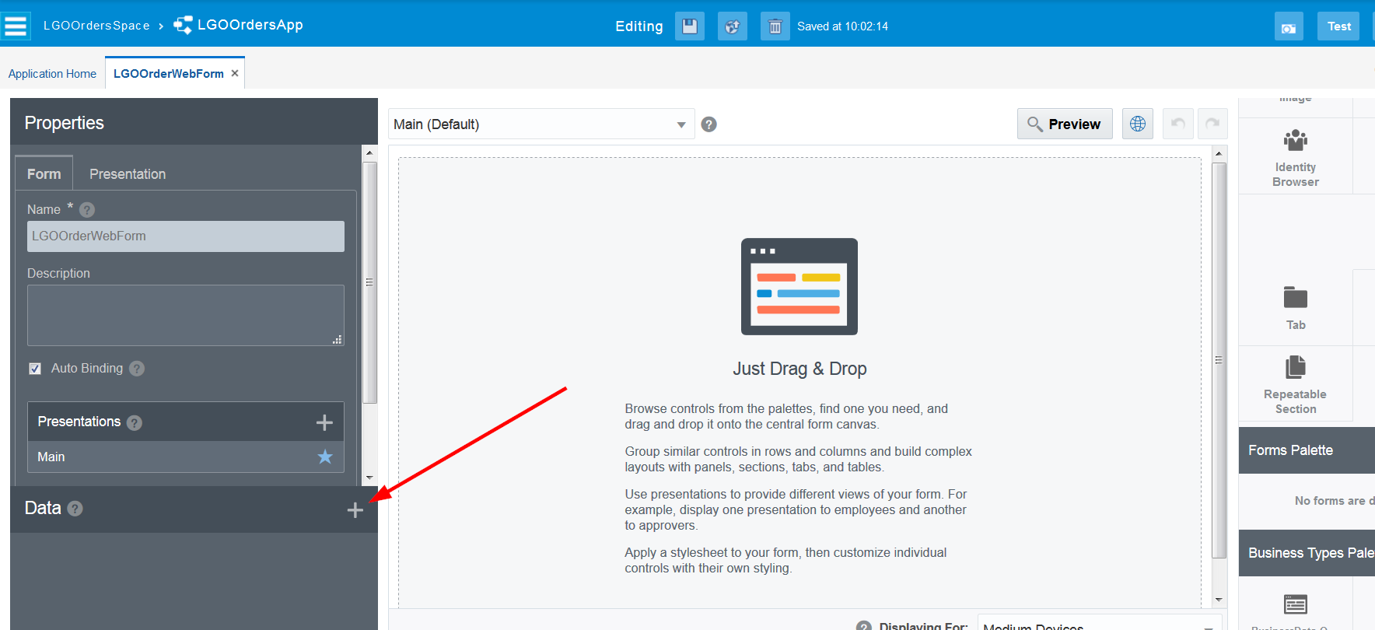

You want to be able to enter/edit an Order with this form. Changing the form to do this is surprisingly simple: drag-and-drop the BusinessData.Order Business type to the form:

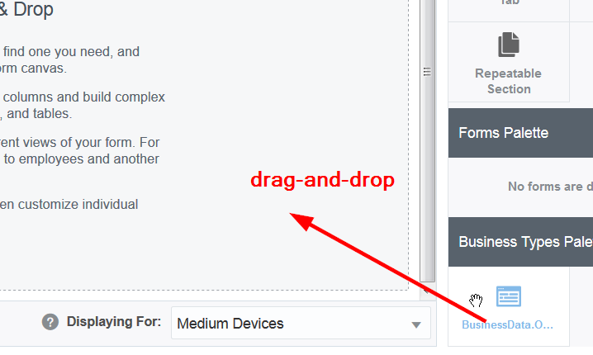

The result looks like:

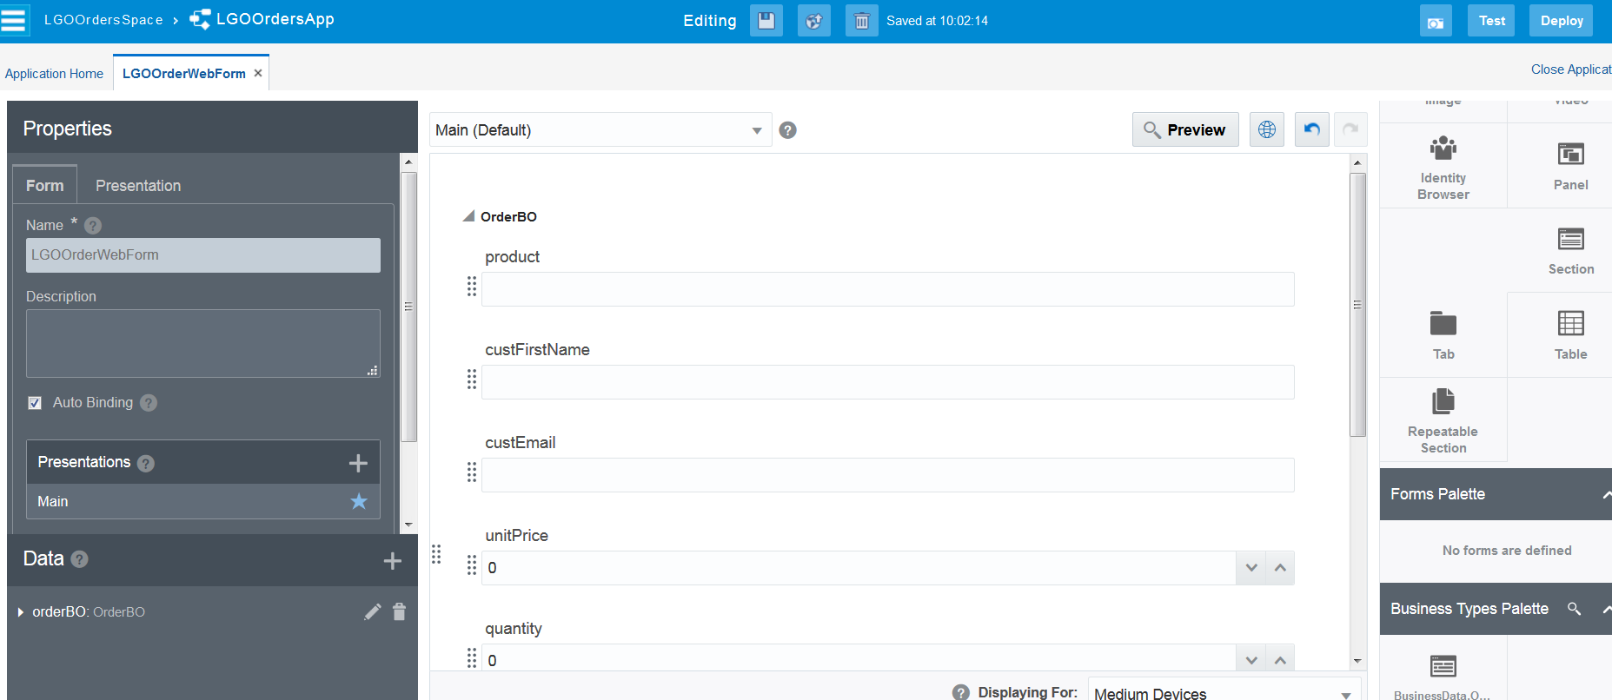

Note: you can, of course, configure each field’s properties via the palette. However, just leave, as is, for now.

Note: you can also click the Preview button to see how your form looks like on different devices:

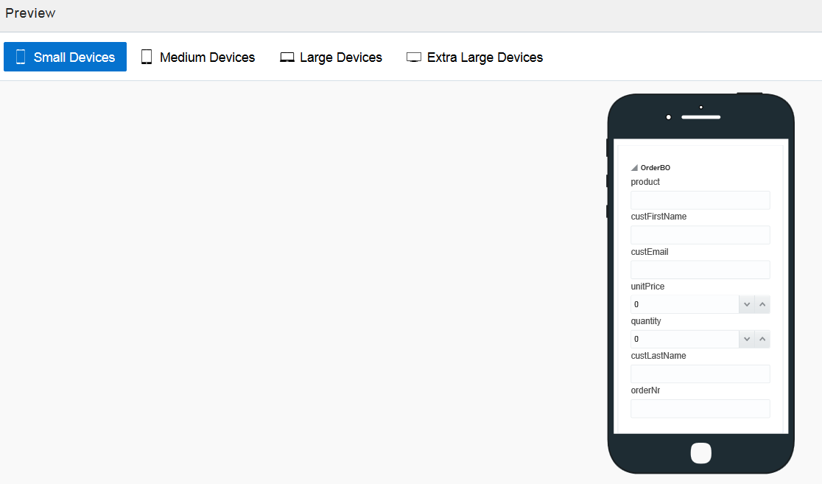

Save!



Click the Application Home link/Tab

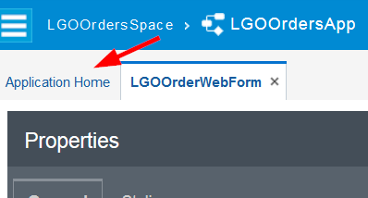

You will see your new form:

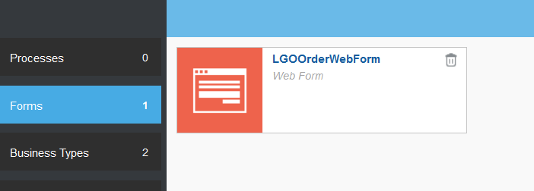

# Create the Order Process – The Happy Path

Now, you will create the process.

Click on Processes

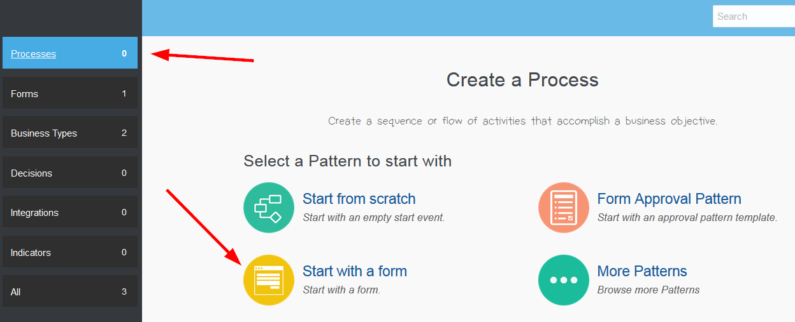

You will select Start with a form

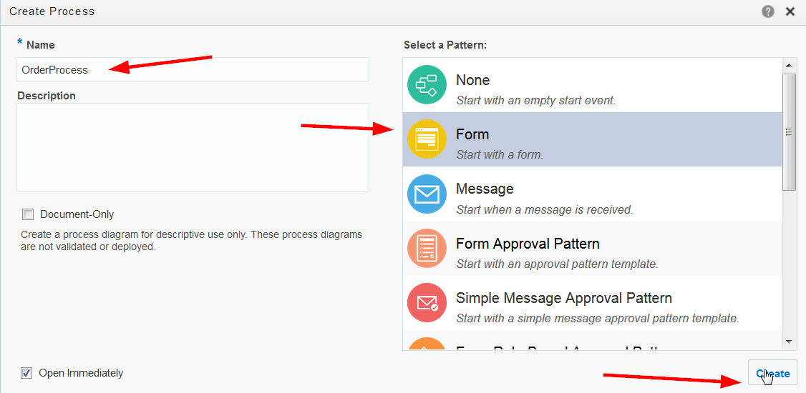

Name the process OrderProcess - make sure the Form pattern is selected and click Create

You will see your basic process:

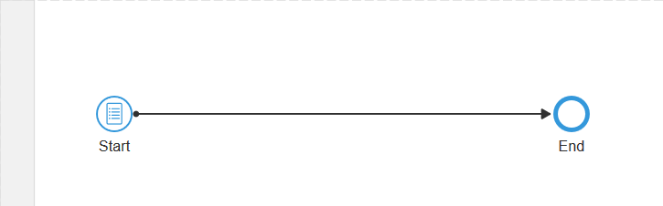

# Add Process Roles

The work that is assigned to the various users of the system is defined by their ‘Role’. In BPMN terminology a role is mapped to a ‘swimlane’, and an activity that is in that swimlane is delivered to any user (or users) who log into the system with that role at the appropriate time.

The default process has one swimlane. Let’s add two more.

Click the ‘+’ icon twice

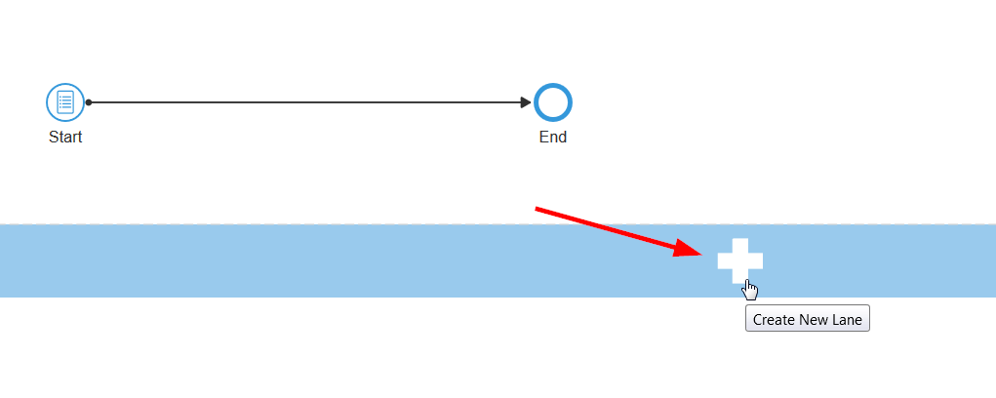

You should see this.

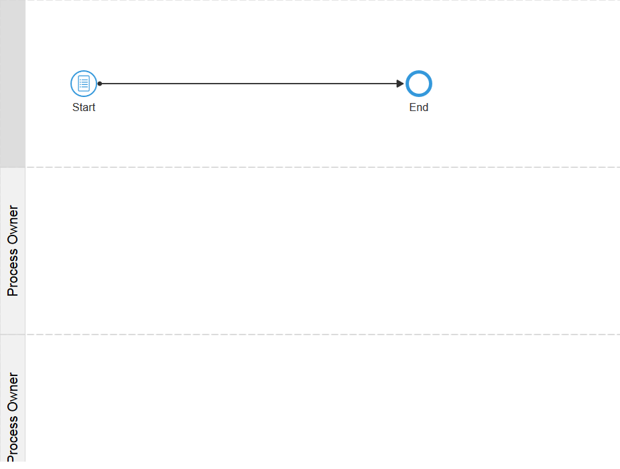

Now we will add the three roles mentioned in the introduction; ‘Order Entry’, ‘Order Approval’ & ‘Order Management’

* Click on the left hand side of the first lane – it will turn blue.
* Double Click on the blue area – this will allow you to edit the lane Role.
* Enter ‘Order Entry’

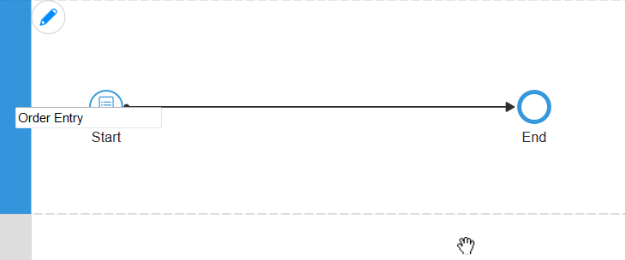

Do the same for the next two Lanes so that your map looks like this.

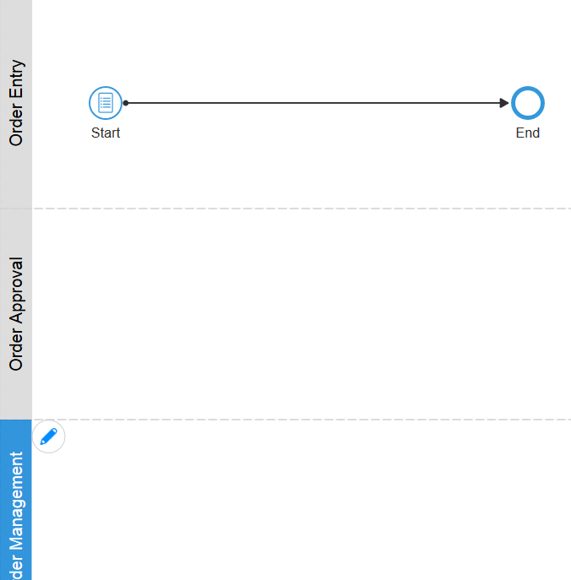

# Add the Process logic

For the start event, we simply need to point to the Web Form you created.

* Specify the form to use

Click the Start event, click the properties and then ‘Open Properties’:

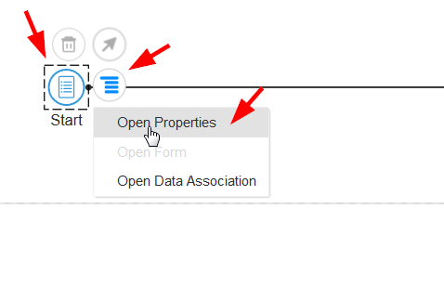

* Enter a title – Order Entry Form - then browse to select the form previously created

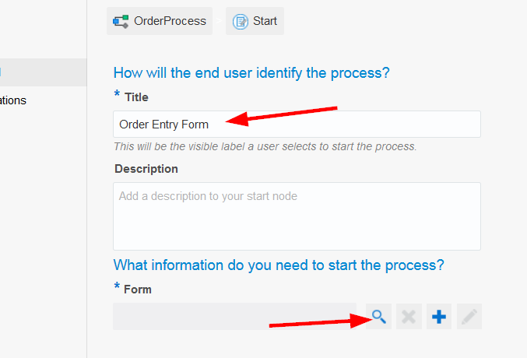

In the pop-up, select the form:

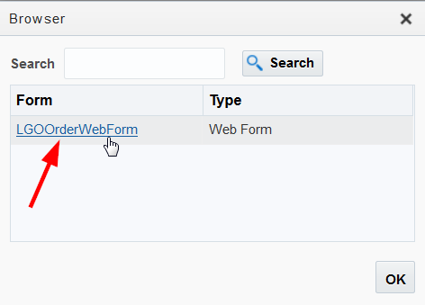

Which results in:

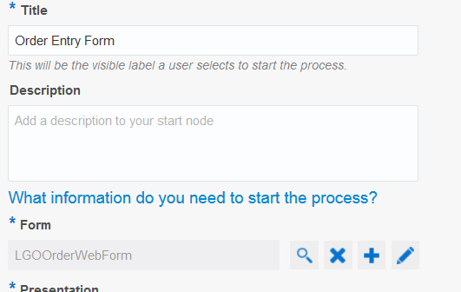

Minimize the properties panel:

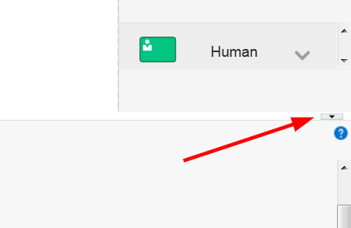

Click Save



Rename the activity from Start to Enter Order (double click on Start)

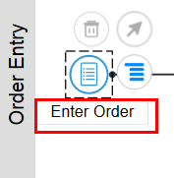

Now you will implement the business logic to approve an order. Remember, the OrderApprovers do this.

Select an Approve task in the right hand palette.

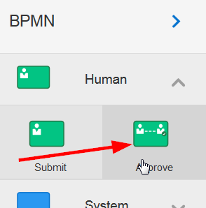

Drag the task onto the line connecting Enter Order to End – when the line will flashes blue, drop the task onto the line.

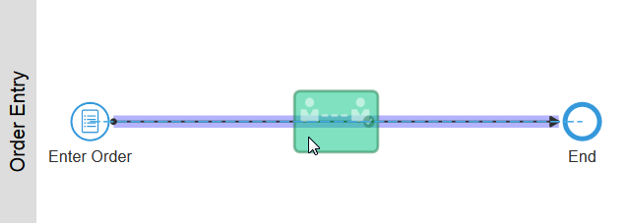

Drag the user task to the OrderApproval Lane

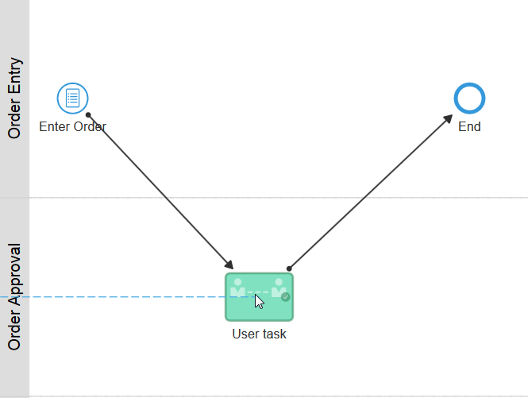

Rename User Task to Approve Order:

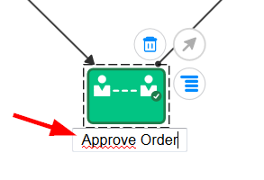

Click the Validate Application icon: Top right, last icon

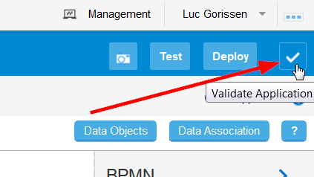

And the validation starts:

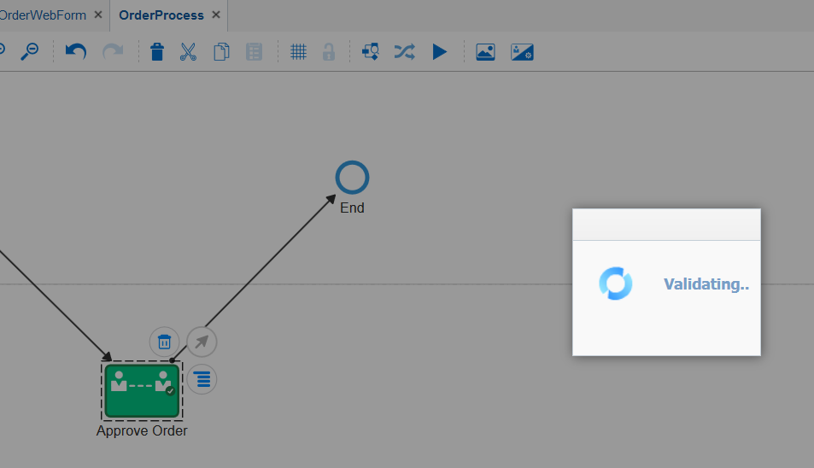

You should see this...

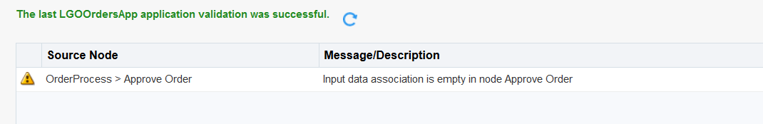

This tells you that the process logic is OK, but it warns you that you have not associated any data with this person’s task – in this case we want the Order data for the approval task. This is done automatically when we assign a Form to the task.

Open the properties for the Approve Order task:

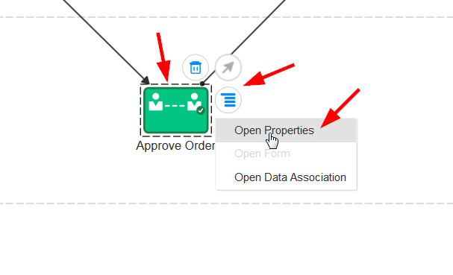

* Enter Title – Approve an Order
* Browse the forms and select the one you created

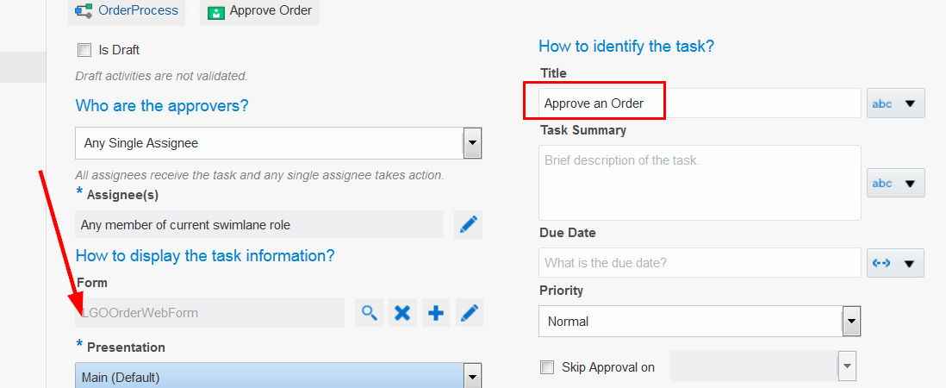

* Click Save
* Collapse the Properties pane (small icon to the right)
* Validate again

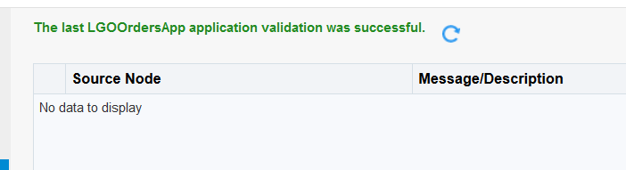

# Testing

Click Test

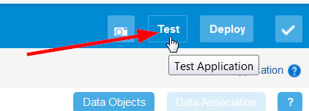

Click Deploy

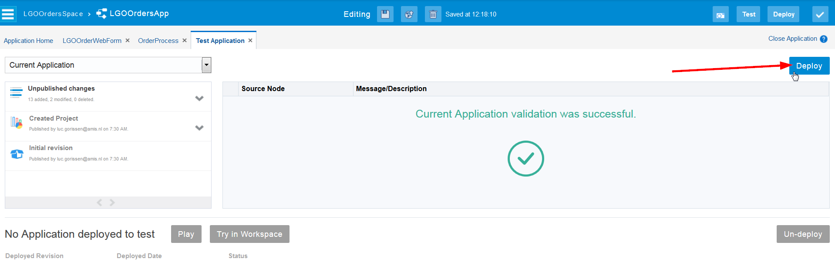

In the pop-up, select ‘Add Me to All Roles’: that makes testing a lot easier…

Click Deploy

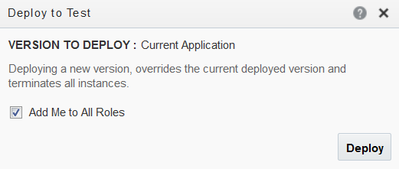

This results in the pop-up:

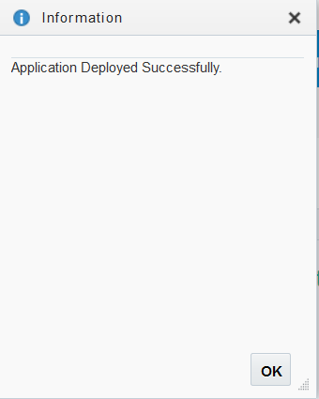

Click OK

Note: You have 2 options for testing, either within the Composer itself via Play, or using the PCS Workspace. The Workspace is the default interface used to approve tasks and monitor process execution.

Select Try in Workspace

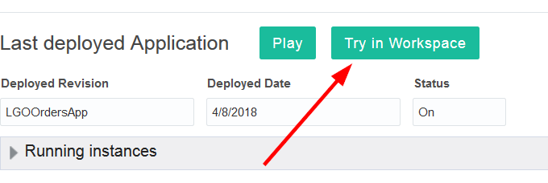

This brings you to a new browser tab:

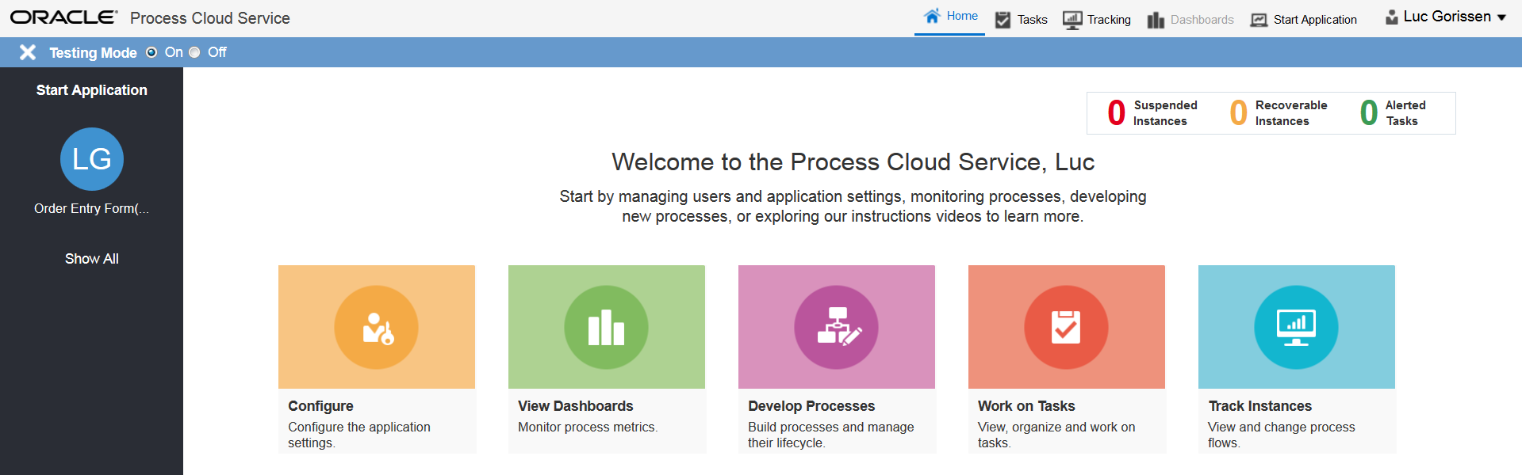

Note: the Start Application panel on the left, shows you the applications which you can start.

Click on the icon that corresponds to you App – AAXXOrdersApp

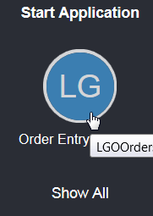

Fill in all the fields, then click Submit

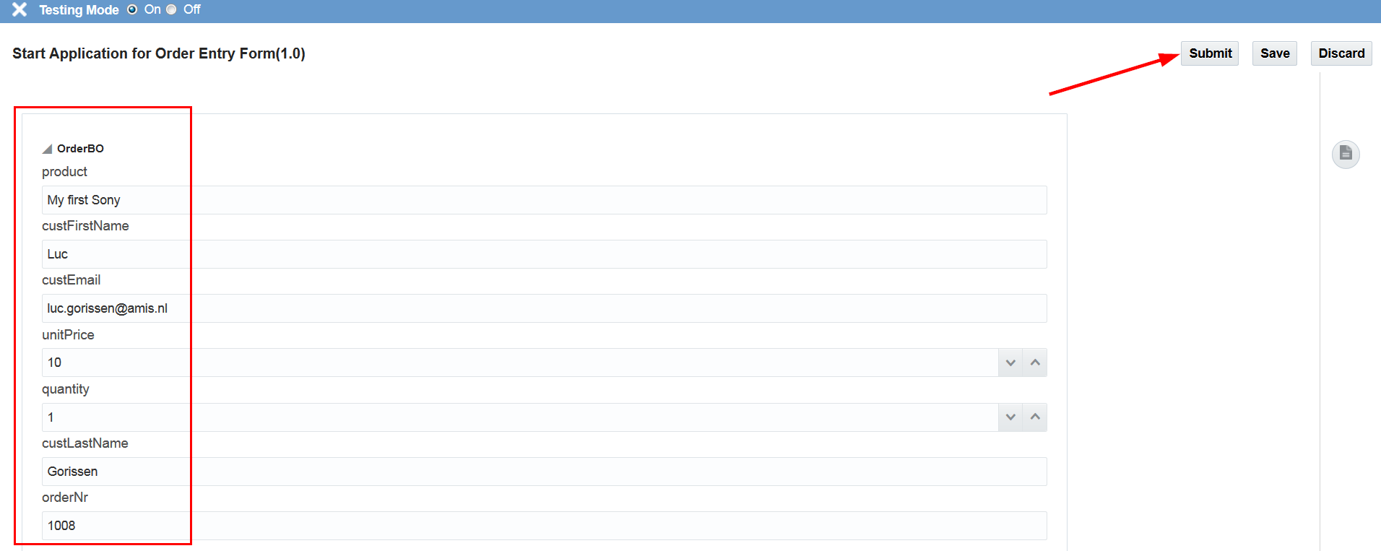

The pop-up shows that you started a process instance:

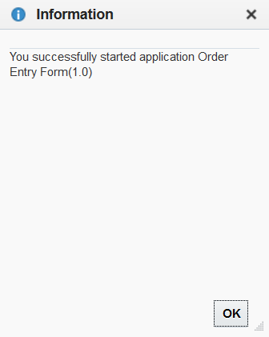

As you are testing, your user has been added to all process roles, so you can approve the order.

Click Work on Tasks

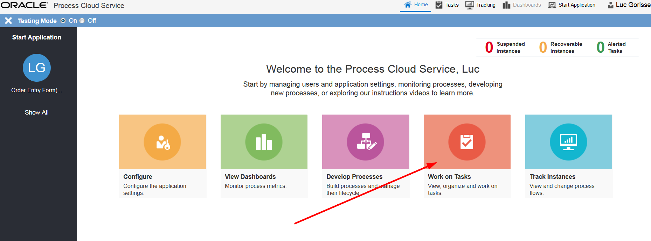

The “Approve order task” will be displayed. Search criteria can be specified in the left panel. Here, one can, for example, also search for completed instances.

But, back to the task at hand, let us approve the order.

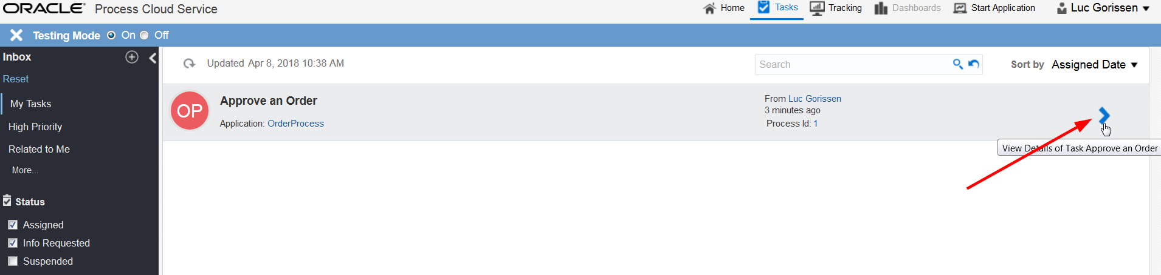

Click on the > icon to see the details

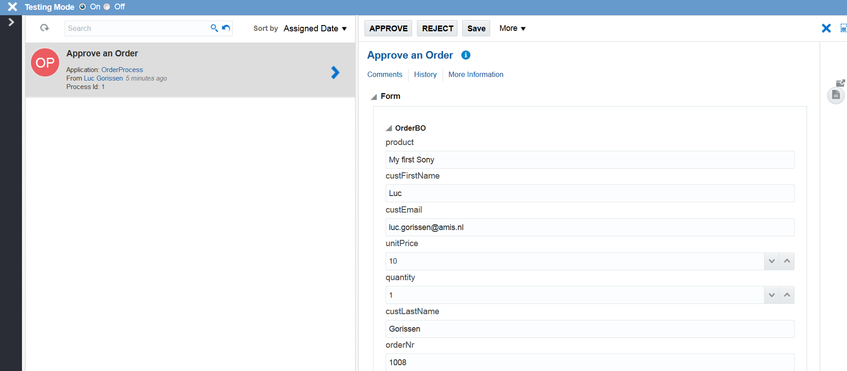

Approve the order

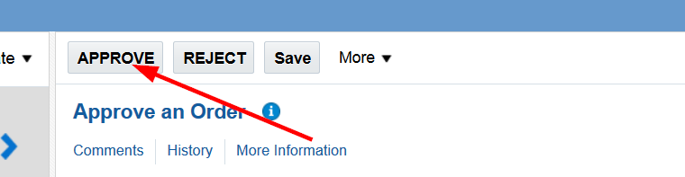

You will now view the process audit trail.

Click on Tracking:

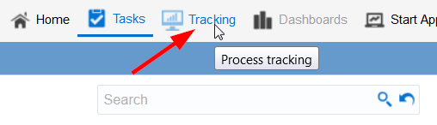

Also select Completed

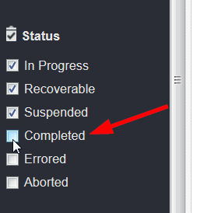

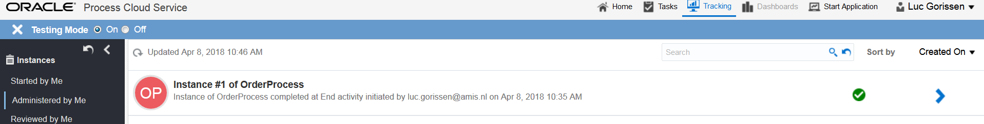

View the process instance details by again clicking the > icon:

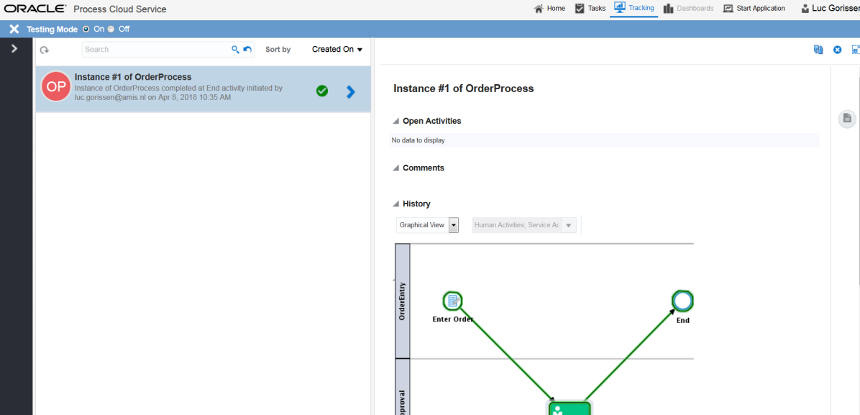

# Adding Process logic

Here you will add the logic to automatically approve orders < €100.

Go back to the Composer (Click Home at the top, go to Develop Processes and open up your Application)

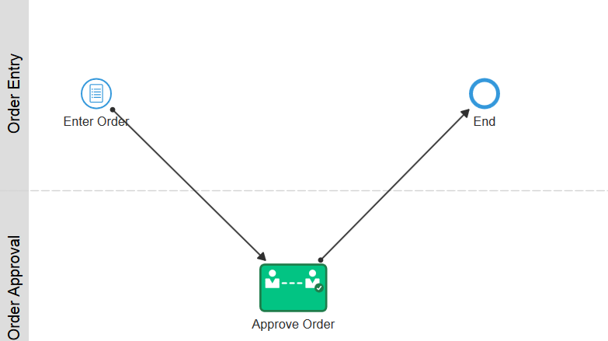

Add a Decision Gate, based on the order value:

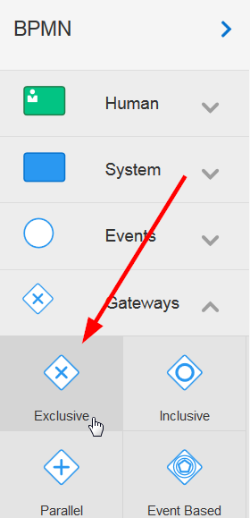

Drop this onto the link between Enter Order and the Approve Order task.

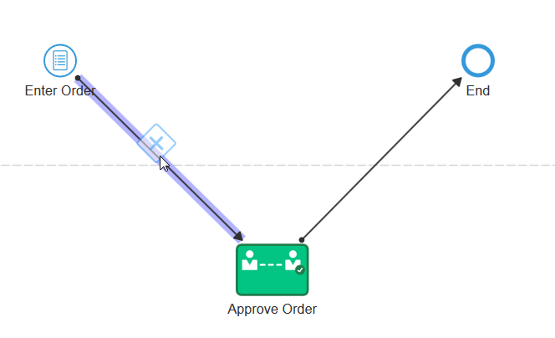

Drag the gateway into the OrderEntry swimlane and select the ‘connections’ arrow.

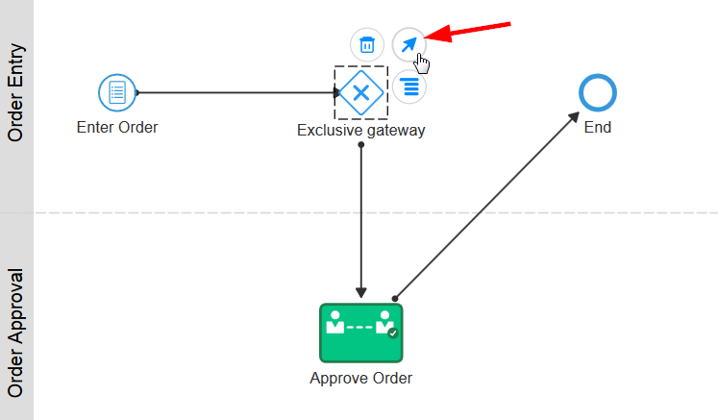

Connect to the End step

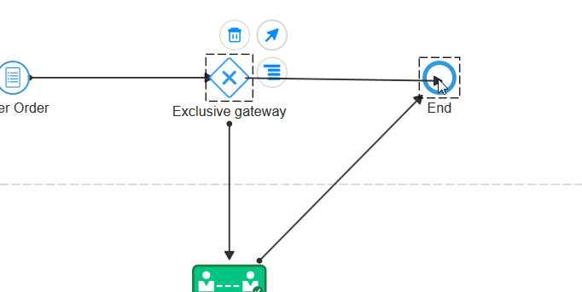

Enter a condition on the Approval path. Note, the ‘slash’ on this path indicates that it is currently the default (or unconditional) path.

Select the path and click the pencil icon:

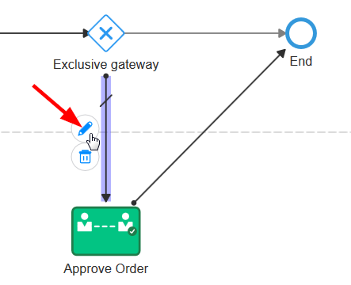

Enter Large Order as the name and then open the Expression Builder to edit the ‘condition’ under which this path is followed. Select ‘Conditional Flow’, then click the pencil icon to open the expression editor:

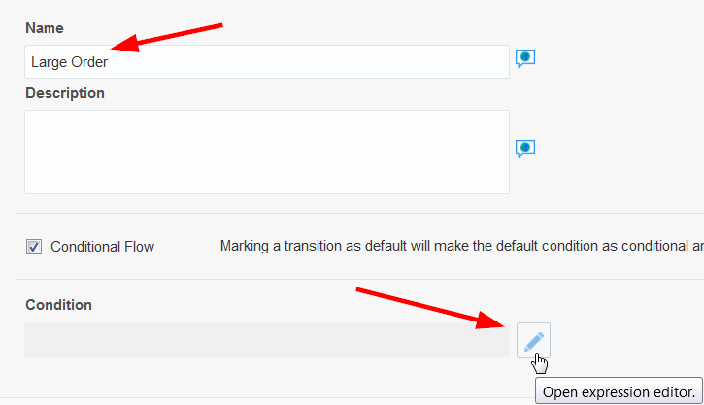

Click on the “AAXXOrderWebFormDataObject” to expand the payload, then on orderBO:

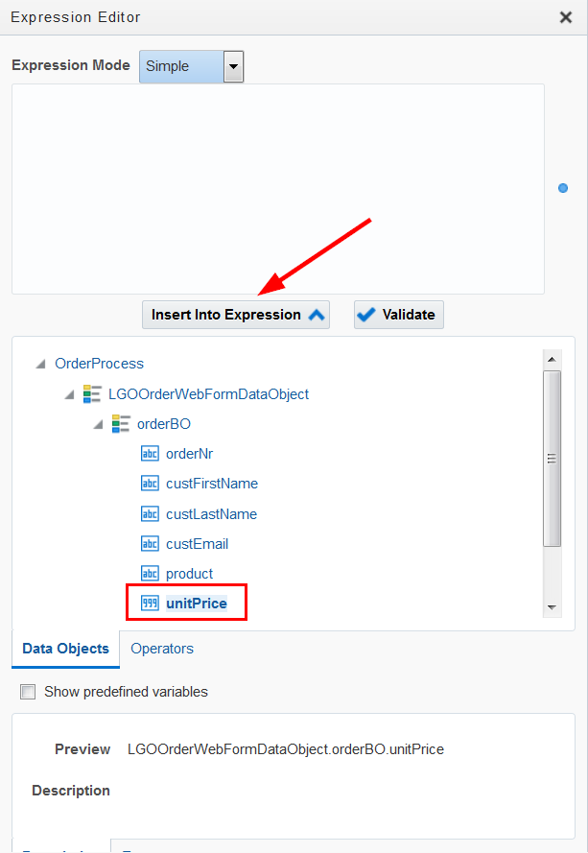

Note: The condition is unitPrice * quantity >= €100 so find the unitPrice object in the payload and select it.

Click on “Insert Into Expression”, and then manually add the multiplication symbol * into the expression builder:

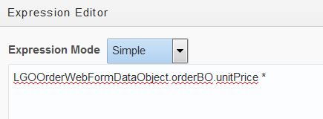

and then find the quantity object from the Data Objects and insert it into the expression:

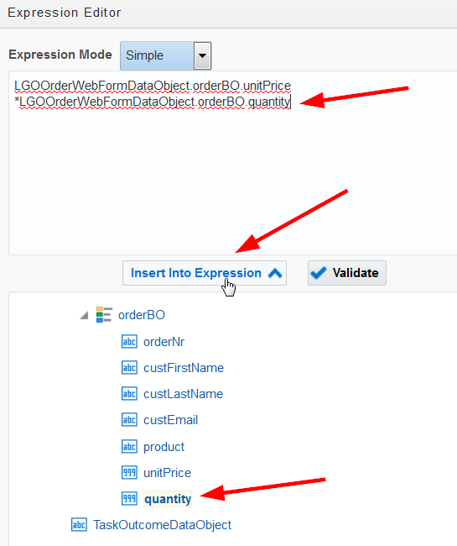

Then complete the condition by adding >= 100

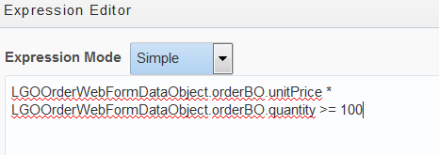

* Click validate to check it is correct syntax
* Click OK (at the bottom) and click Save
* Minimise the entry panel

Finally, remove the condition on the straight-through route:

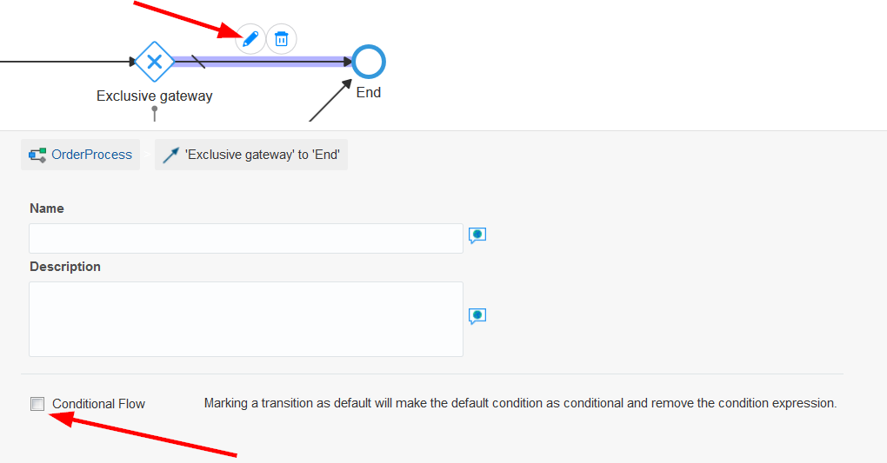

Now you will add the logic to escalate REJECTED orders to management.

Add an Exclusive Gateway after the Approve Order task

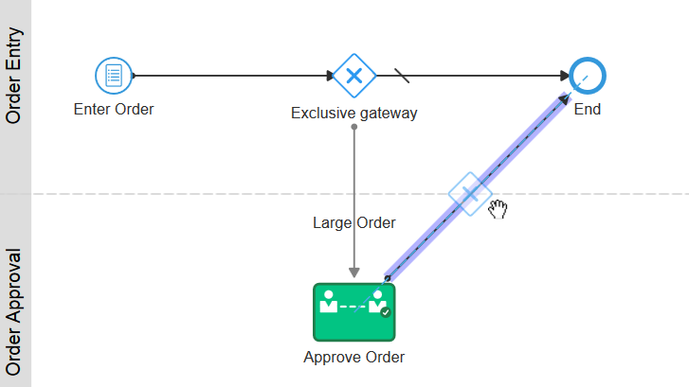

Which results in:

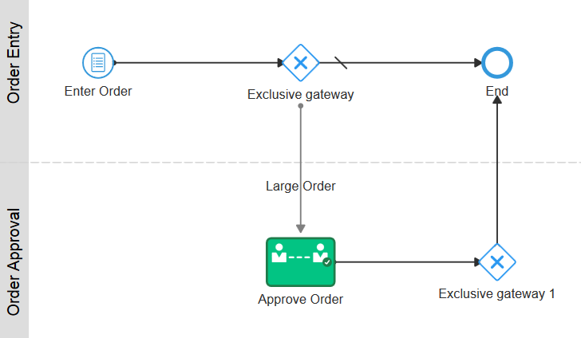

Add a new Approval Task to the OrderManagement swimlane

Configure as per the Approve Order task, except for giving it a different name – ‘Management Approval’.

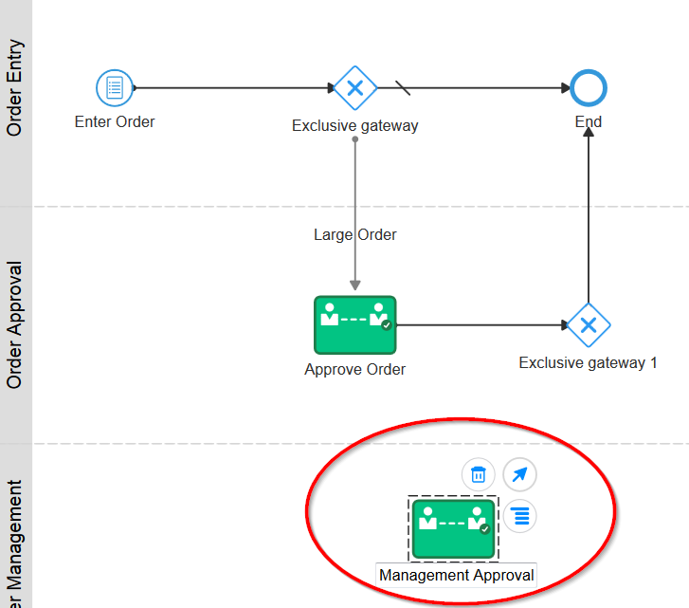

Open the properties for this task:

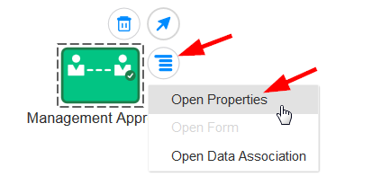

* Populate the Title to Management Approval
* Then add the Order Approval form in the “Form” field

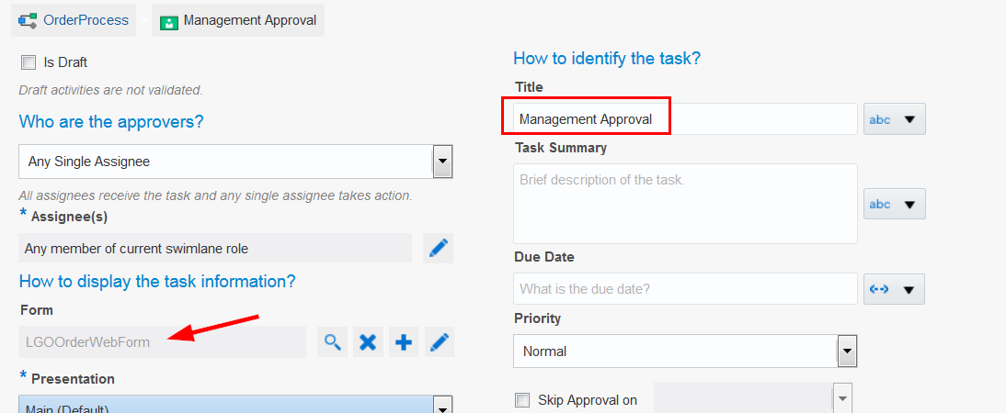

* Click Save
* Minimize the Panel

Connect: from ‘Exclusive gateway 1’:

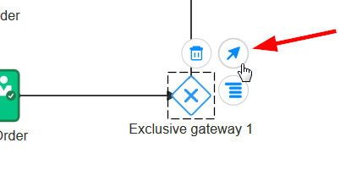

Connect: to Management Approval:

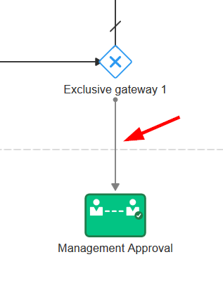

Rename both Gateways:

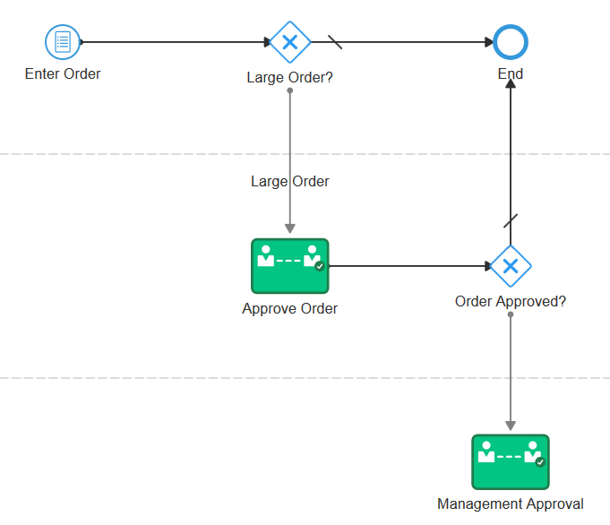

Enter the condition for the transition to Management Approval:

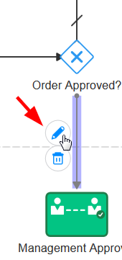

Complete the Name and then open the expression editor:

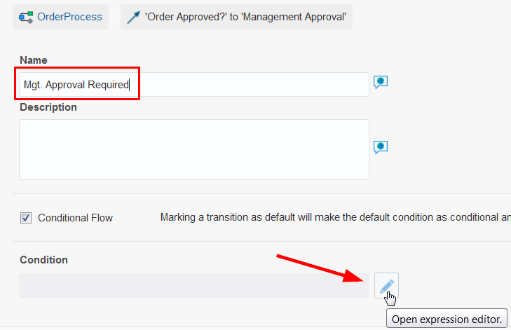

In the expression editor:

* Select the TaskOutcomeDataObject and click ‘Insert Into Expression’
* Complete the expression with ‘= “REJECT” ‘

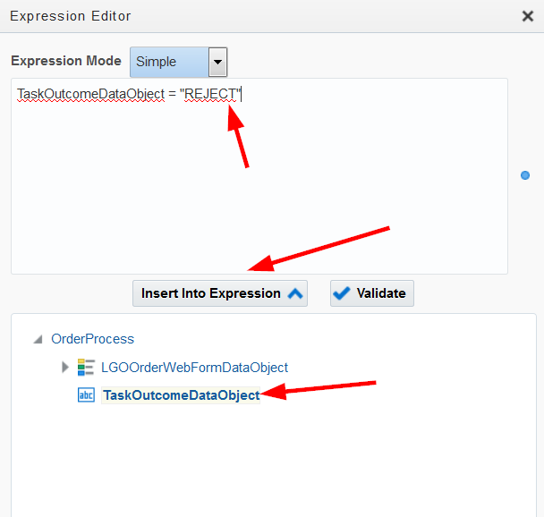

* Click Ok and Save
* Minimise the panel
* Add a path between Management Approval and End.

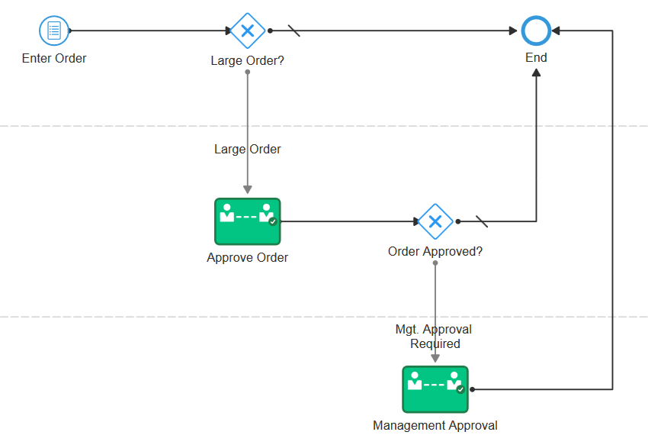

Note: You probably would require yet another Gateway here for a Management Approval ‘Reject’ option, but for the sake of time, do not implement this.

Validate your process

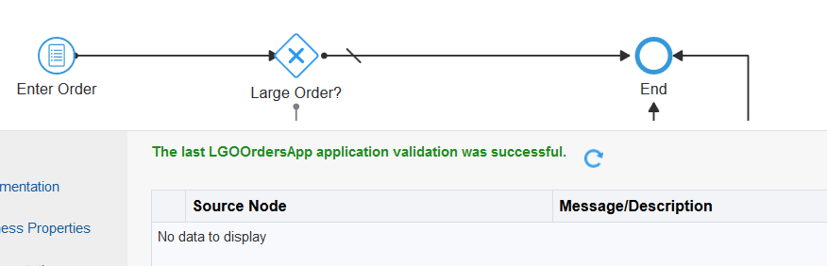

Click on Test



…Deploy (remember to use the ‘Deploy’ in the test page)

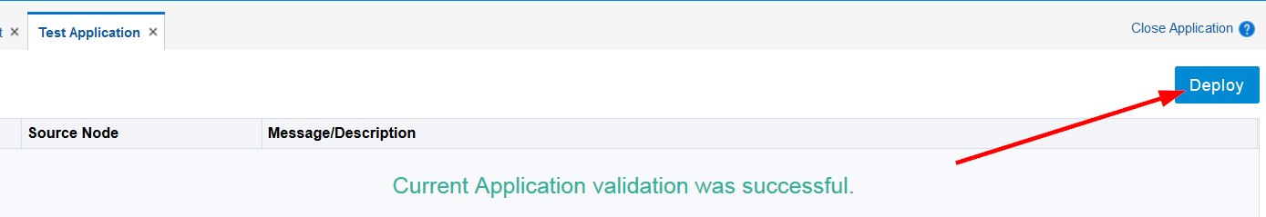

…Try in Workspace

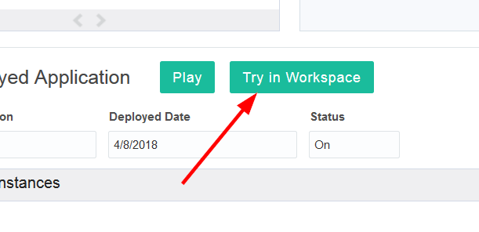

In the Workspace, start an order:

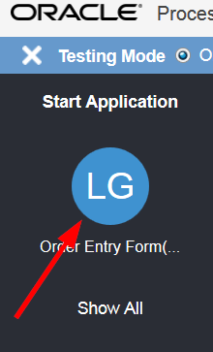

Enter a small order that will have a total value less than 100:

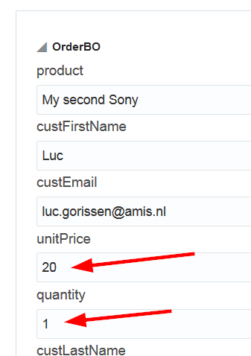

Click Submit.

Click on Work on Tasks:

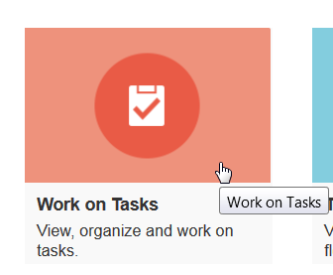

And observe… that you have no tasks:

* Why is this ?
* Check the audit trail (Tracking)
  + Remember to also select Completed

And check the details of the latest instance

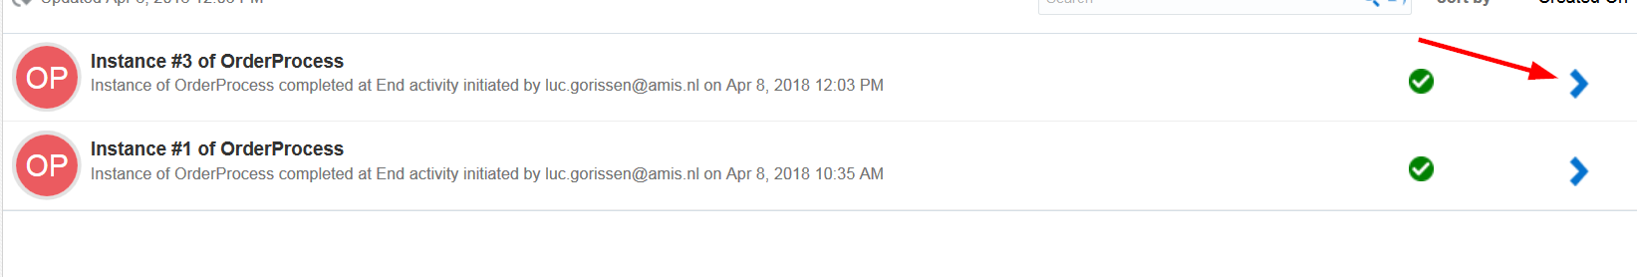

Observe the execution path:

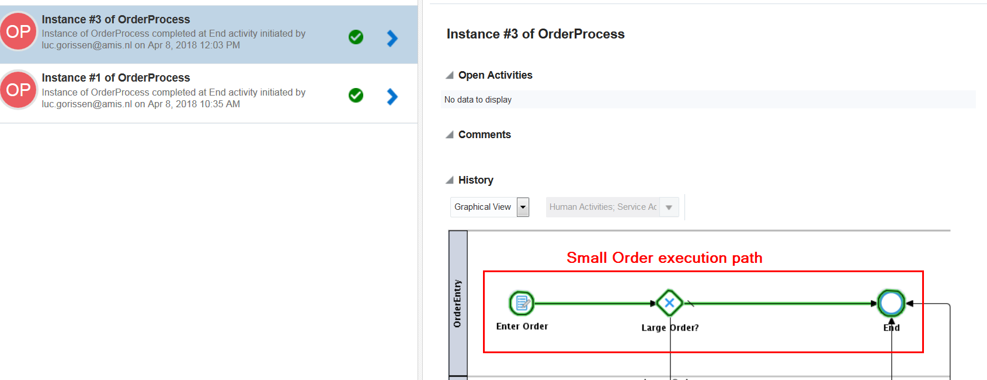

You can see that, because the order was less than 100, it did not require approval.

Try a second test, where you REJECT a large order (>100). Then do the Management Approval and review the Audit trail.

* Enter the order
* Look at Tasks – it should be there at the Approve Order Stage
* Reject the Order
* Look at tasks again – it will be at the Management Approval Stage
* Approve the Order
* Review the History (Tracking)

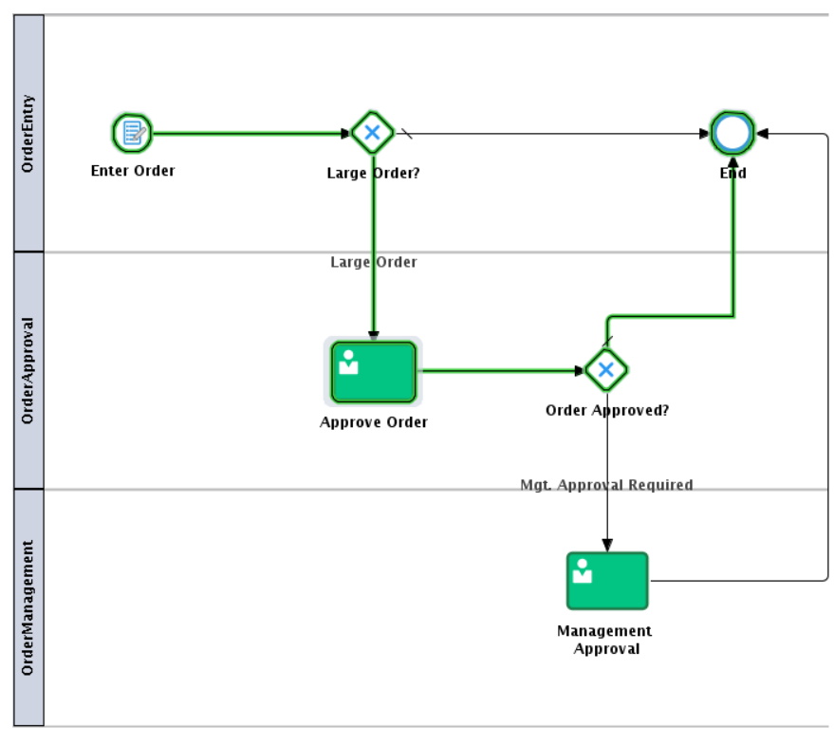

CONGRATULATIONS – YOU HAVE FINISHED THE LAB !